-- =========================================
-- SECTION B - TASK 1
-- Design and Populate a Restaurant Database
-- =========================================

CREATE DATABASE foodapp_db;

USE foodapp_db;

CREATE TABLE restaurants
(
restaurant_id INT AUTO_INCREMENT PRIMARY KEY,
name VARCHAR(100) NOT NULL,
city VARCHAR(50),
cuisine_type VARCHAR(50),
rating DECIMAL(3,1)
);

-- Insert 6 restaurant records
INSERT INTO restaurants (name, city, cuisine_type, rating)
VALUES
('Spice Garden', 'Ahmedabad', 'Indian', 4.5),
('Pizza Point', 'Vadodara', 'Italian', 4.2),
('Food Palace', 'Surat', 'Gujarati', 4.6),
('Burger House', 'Ahmedabad', 'Fast Food', 4.0),
('South Cafe', 'Vadodara', 'South Indian', 4.3),
('Royal Kitchen', 'Surat', 'Punjabi', 4.1);

-- Display records
SELECT * FROM restaurants;

-- Update rating of one restaurant
UPDATE restaurants
SET rating = 4.8
WHERE restaurant_id = 1;

-- Delete one restaurant
DELETE FROM restaurants
WHERE restaurant_id = 6;

-- Display restaurants by rating
SELECT * FROM restaurants
ORDER BY rating DESC;

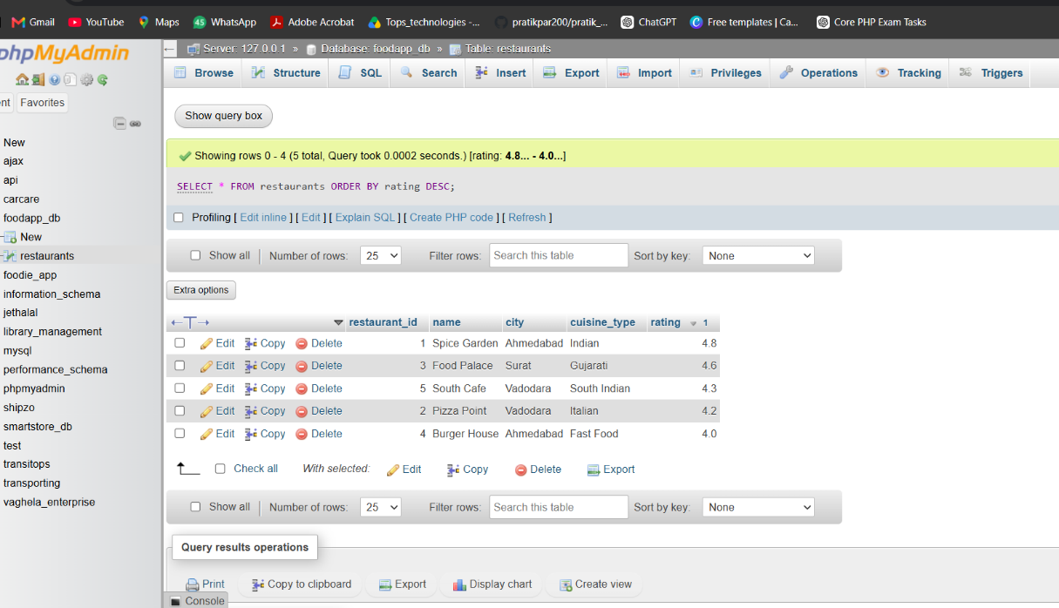

-- =========================================
-- SECTION B - TASK 2
-- Aggregate Revenue Reporting
-- =========================================

USE foodapp_db;

CREATE TABLE orders
(
order_id INT AUTO_INCREMENT PRIMARY KEY,
restaurant_id INT,
customer_name VARCHAR(100),
total_amount DECIMAL(10,2),
order_date DATE
);

-- Insert 12 orders
INSERT INTO orders
(restaurant_id, customer_name, total_amount, order_date)
VALUES
(1, 'Rahul', 2500.00, '2026-09-01'),
(1, 'Amit', 1800.00, '2026-09-03'),
(1, 'Neha', 2200.00, '2026-09-05'),

(2, 'Ravi', 1200.00, '2026-09-06'),
(2, 'Karan', 1500.00, '2026-09-08'),
(2, 'Priya', 2800.00, '2026-09-10'),

(3, 'Jay', 3000.00, '2026-09-12'),
(3, 'Mehul', 2500.00, '2026-09-14'),
(3, 'Riya', 2000.00, '2026-09-16'),

(4, 'Dhruv', 900.00, '2026-09-18'),
(4, 'Krish', 1100.00, '2026-09-20'),
(4, 'Pooja', 1300.00, '2026-09-22');

-- Total revenue and average order value per restaurant
SELECT
restaurant_id,
SUM(total_amount) AS total_revenue,
AVG(total_amount) AS average_order_value
FROM orders
GROUP BY restaurant_id;

-- Restaurants whose total revenue exceeds Rs 5000
SELECT
restaurant_id,
SUM(total_amount) AS total_revenue
FROM orders
GROUP BY restaurant_id
HAVING SUM(total_amount) > 5000;

-- 5 most recent orders
SELECT *
FROM orders
ORDER BY order_date DESC
LIMIT 5;

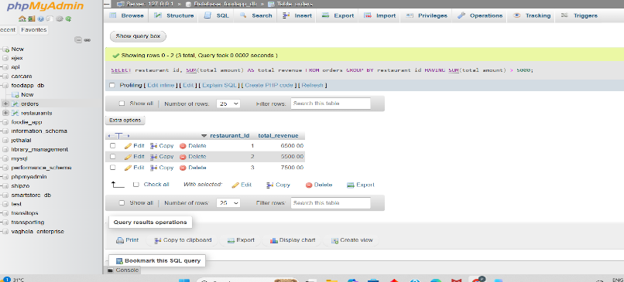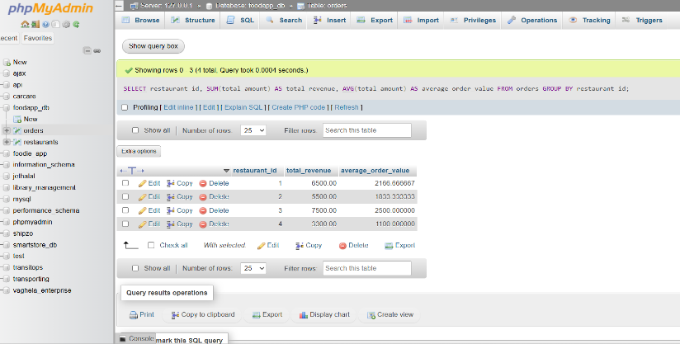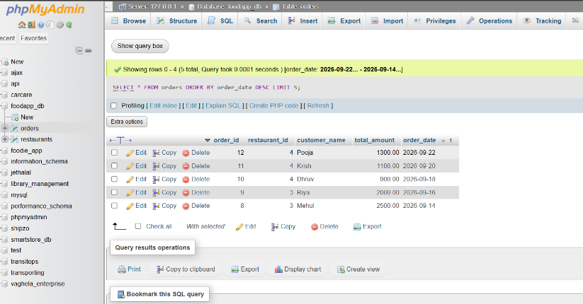

-- =========================================
-- SECTION B - TASK 3
-- Multi-Table JOINs and Menu Summary View
-- =========================================

CREATE DATABASE foodapp_task3;

USE foodapp_task3;

-- Create restaurants table
CREATE TABLE restaurants
(
restaurant_id INT AUTO_INCREMENT PRIMARY KEY,
name VARCHAR(100) NOT NULL,
city VARCHAR(50)
);

-- Create menu_items table
CREATE TABLE menu_items
(
item_id INT AUTO_INCREMENT PRIMARY KEY,
restaurant_id INT,
item_name VARCHAR(100),
price DECIMAL(10,2),
category VARCHAR(50),

FOREIGN KEY (restaurant_id)
REFERENCES restaurants(restaurant_id)
);

-- Insert 5 restaurants
INSERT INTO restaurants (name, city)
VALUES
('Spice Garden', 'Ahmedabad'),
('Pizza Point', 'Vadodara'),
('Food Palace', 'Surat'),
('Burger House', 'Ahmedabad'),
('Royal Kitchen', 'Rajkot');

-- Insert 12 menu items
-- Restaurant 5 intentionally has no menu item

INSERT INTO menu_items
(restaurant_id, item_name, price, category)
VALUES
(1, 'Paneer Tikka', 250.00, 'Starter'),
(1, 'Paneer Butter Masala', 320.00, 'Main Course'),
(1, 'Butter Roti', 40.00, 'Bread'),

(2, 'Margherita Pizza', 299.00, 'Pizza'),
(2, 'Farmhouse Pizza', 399.00, 'Pizza'),
(2, 'Garlic Bread', 180.00, 'Starter'),

(3, 'Gujarati Thali', 300.00, 'Main Course'),
(3, 'Dal Rice', 180.00, 'Main Course'),
(3, 'Chaas', 50.00, 'Drink'),

(4, 'Veg Burger', 150.00, 'Burger'),
(4, 'Cheese Burger', 190.00, 'Burger'),
(4, 'French Fries', 120.00, 'Starter');

-- INNER JOIN
SELECT
restaurants.name AS restaurant_name,
menu_items.item_name,
menu_items.price
FROM restaurants
INNER JOIN menu_items
ON restaurants.restaurant_id = menu_items.restaurant_id;

-- LEFT JOIN
SELECT
restaurants.name AS restaurant_name,
menu_items.item_name,
menu_items.price
FROM restaurants
LEFT JOIN menu_items
ON restaurants.restaurant_id = menu_items.restaurant_id;

-- Create View
CREATE VIEW restaurant_menu_summary AS
SELECT
restaurants.name AS restaurant_name,
COUNT(menu_items.item_id) AS total_menu_items,
AVG(menu_items.price) AS average_item_price
FROM restaurants
LEFT JOIN menu_items
ON restaurants.restaurant_id = menu_items.restaurant_id
GROUP BY restaurants.restaurant_id, restaurants.name;

-- Display View
SELECT * FROM restaurant_menu_summary;

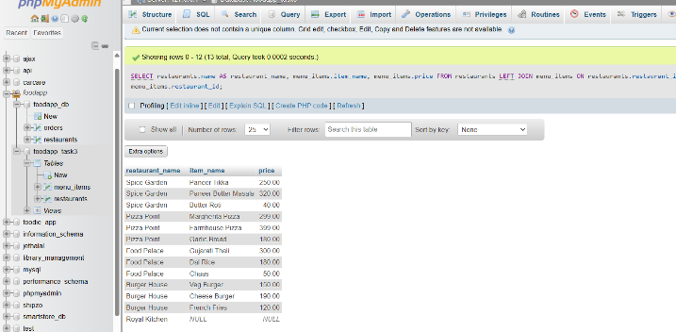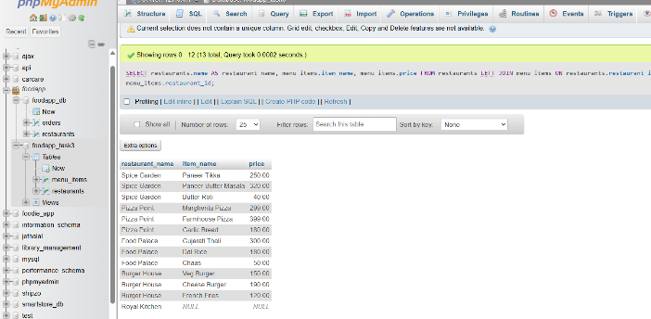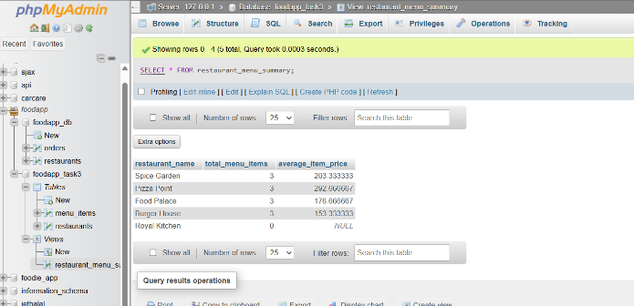

-- =========================================
-- SECTION B - TASK 4
-- Order Placement Stored Procedure
-- =========================================

CREATE DATABASE foodapp_task4;

USE foodapp_task4;

-- Customers table
CREATE TABLE customers
(
customer_id INT AUTO_INCREMENT PRIMARY KEY,
customer_name VARCHAR(100) NOT NULL,
wallet_balance DECIMAL(10,2) NOT NULL
);

-- Orders table
CREATE TABLE orders
(
order_id INT AUTO_INCREMENT PRIMARY KEY,
customer_id INT,
restaurant_id INT,
total_amount DECIMAL(10,2),
order_date DATETIME DEFAULT CURRENT_TIMESTAMP
);

-- Insert customers
INSERT INTO customers
(customer_name, wallet_balance)
VALUES
('Rahul', 5000.00),
('Amit', 2000.00),
('Neha', 1000.00);

SELECT * FROM customers;